E-Commerce Sales Analytics using MySQL

Contents:
- Project Overview
- Database Schema
- Business Questions and Analysis
- Key Findings and Business Insights
- Business Recommendations
- Conclusion

1. Project Overview
The objective of this project is to analyze e-commerce sales data using MySQL and generate actionable business insights. The project focuses on understanding revenue trends, customer purchasing behavior, product performance, category-wise sales, regional sales distribution, customer segmentation, and business growth patterns. Various SQL techniques such as Joins, Aggregate Functions, Subqueries, Common Table Expressions (CTEs), and Window Functions were used to perform data analysis and support business decision-making.

Project Objectives
- Analyze overall business revenue.
- Identify top-performing products and categories.
- Identify high-value customers.
- Analyze customer purchase behavior.
- Measure monthly revenue growth.
- Perform customer segmentation.
- Conduct RFM and Cohort Analysis.
- Generate business recommendations based on data.

2. Database Schema
The database consists of three tables: Customers, Products, and Orders. The Orders table acts as a transaction table and connects Customers and Products through their respective IDs.

Entity Relationship Structure
Customers
|
Customer_ID
|
Orders
|
Product_ID
|
Products

Table Descriptions
Table Name | Description
Customers | Stores customer information
Products | Stores product information
Orders | Stores transaction details

Customers Table
Column Name | Description
Customer_ID | Unique Customer Identifier
Customer_Name | Customer Name
City | Customer City
State | Customer State

Products Table
Column Name | Description
Product_ID | Unique Product Identifier
Product_Name | Product Name
Category | Product Category
Price | Product Price

Orders Table
Column Name | Description
Order_ID | Unique Order Identifier
Customer_ID | Customer placing order
Product_ID | Product purchased
Order_Date | Date of purchase
Quantity | Quantity purchased

3. Business Questions and Analysis
The following business questions were analyzed using SQL to generate meaningful insights from the e-commerce sales dataset.
1. What is the total revenue generated by the business?
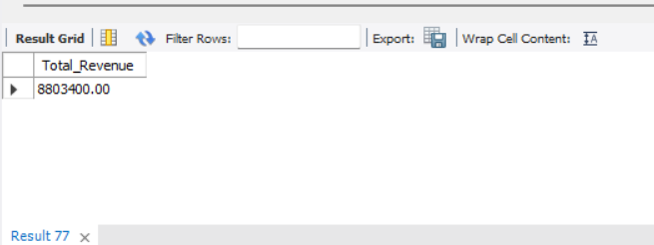
2. Which products generate the highest revenue?
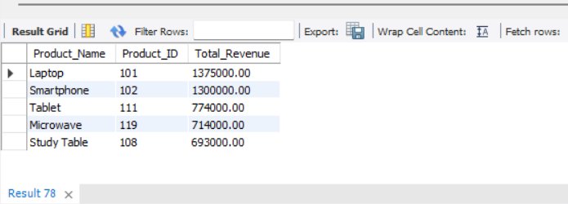
3. Which customers contribute the highest revenue?
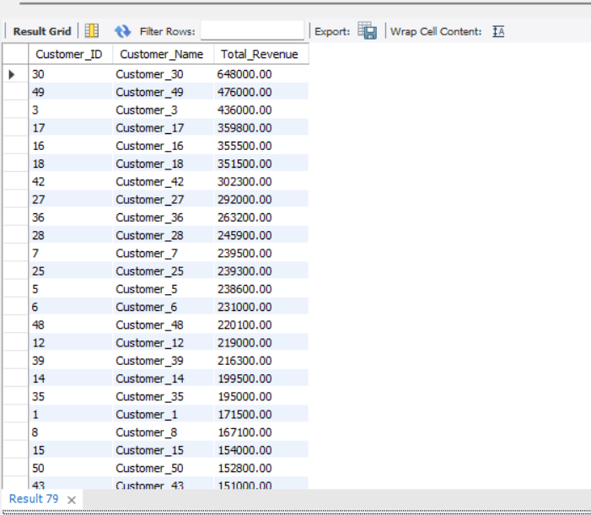
4. Which product categories generate the highest revenue?
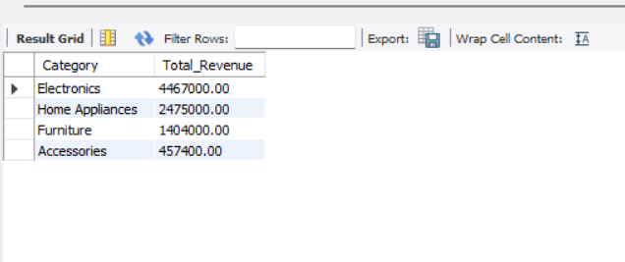
5. Which states contribute the most revenue?
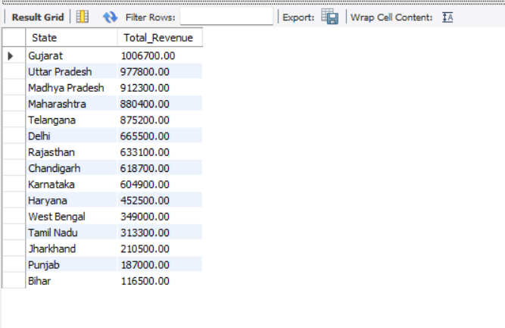
6. What are the top 5 best-selling products by quantity sold?
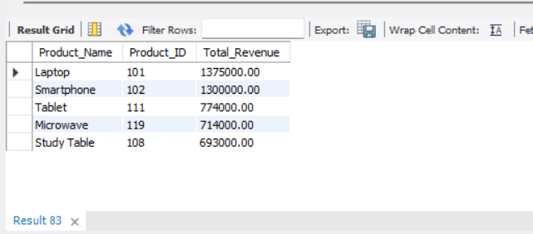
7. What is the Average Order Value (AOV)?
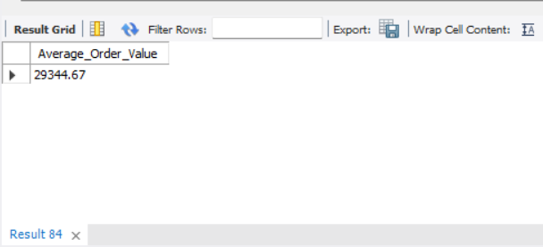
8. Which customers are repeat customers?
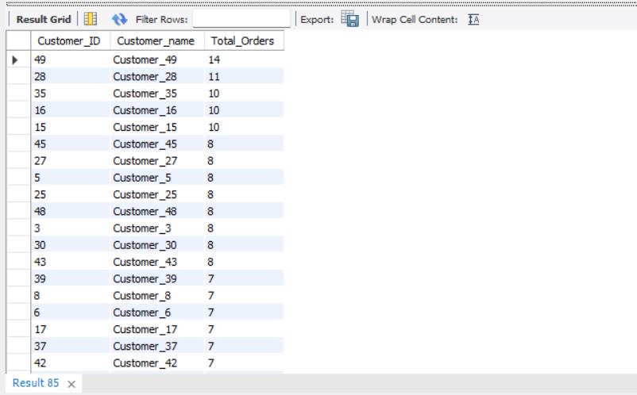
9. How does revenue vary month by month?
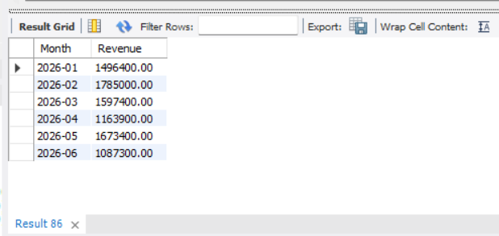
10. Who is the highest revenue-generating customer?
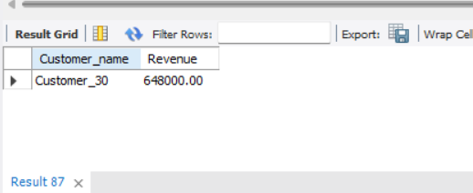
11. Which products have never been sold?
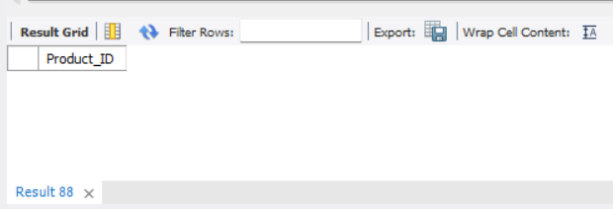
(Hence, every product has been sold at least once).
12. What is the Customer Lifetime Value (CLV) of each customer?
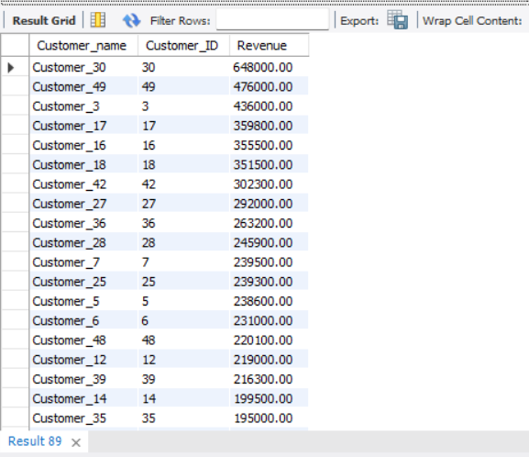
13. What percentage of total revenue is contributed by each product category?
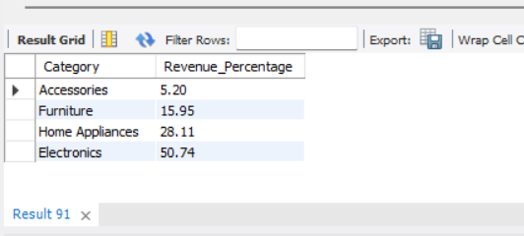
14. Which product generates the highest revenue within each category?
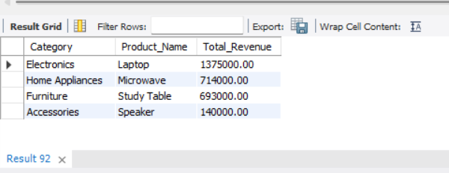
15. What is the month-over-month revenue growth percentage?
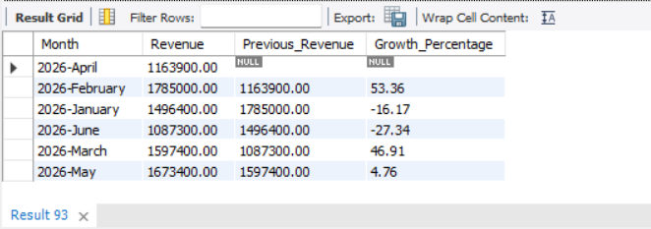
16. How can customers be segmented into High, Medium, and Low Value groups?
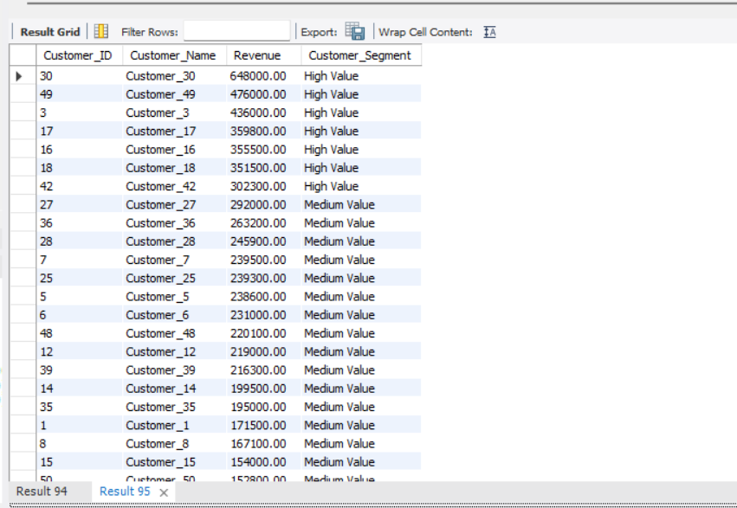
17. Which customers contribute the largest share of total revenue (Pareto Analysis)?
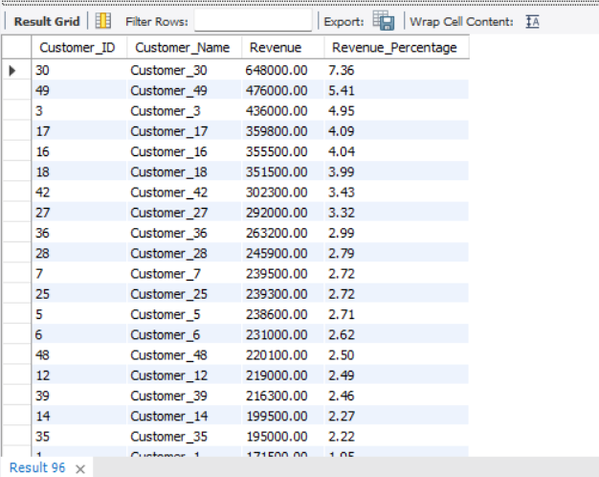
18. Which customers are most valuable based on Recency, Frequency, and Monetary Value (RFM Analysis)?
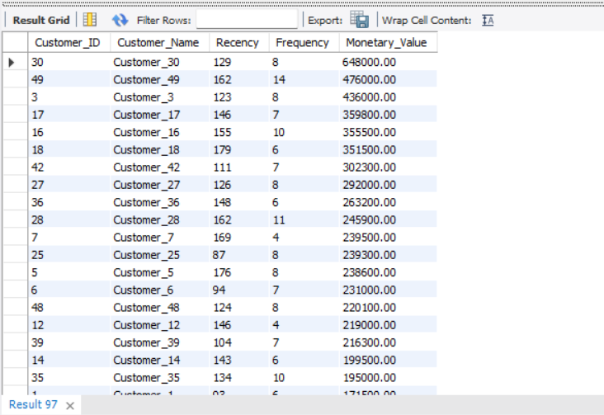
19. What are the customer acquisition trends by cohort month (Cohort Analysis)?
(Do customers return after their first purchase?)
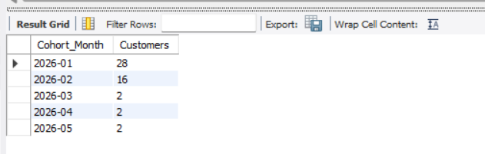
20. What is the market share contribution of each state?
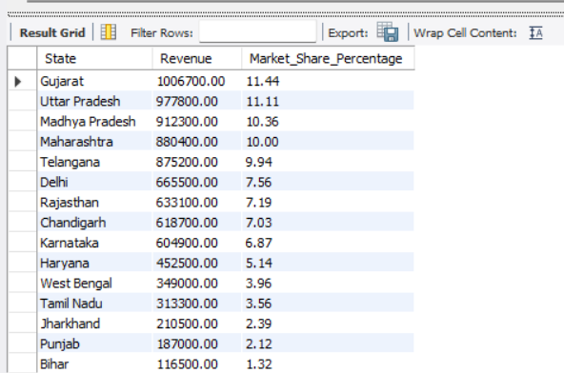

4. Key Findings and Business Insights

Revenue Insights
- Total Revenue generated by the business was ₹8803400
- The Average Order Value (AOV) was ₹29344.67
- Revenue growth peaked in 2026-February with a growth rate of 53.36 %.

Customer Insights
- The highest revenue-generating customer was Customer_30 with total revenue of ₹648000.
- High-value customers contributed a significant share of overall revenue.
- Repeat customers demonstrated stronger purchasing behavior compared to one-time customers.

Product Insights
- The top-performing product was Laptop with revenue of ₹1375000.
- The highest revenue-generating category was Electronics with revenue of ₹4467000.
- Product performance analysis identified key products driving overall business revenue.

Regional Insights
- The highest revenue-generating state was Gujarat with revenue of ₹1006700.
- State-wise analysis revealed geographical concentration of sales and revenue.
- Market share analysis highlighted the strongest performing regions.

Advanced Analytics Insights
- Customer Segmentation identified High, Medium, and Low Value customer groups.
- Pareto Analysis showed that a small percentage of customers contributed a large share of total revenue.
- RFM Analysis helped identify the most valuable customers based on Recency, Frequency, and Monetary Value.
- Cohort Analysis provided visibility into customer acquisition and retention trends.

5. Business Recommendations
- Recommendation 1: Implement a customer loyalty program targeting high-value customers to improve retention and increase repeat purchases.
- Recommendation 2: Increase inventory availability and promotional efforts for top-performing products and categories to maximize revenue growth.
- Recommendation 3: Focus marketing investments in high-performing states while exploring growth opportunities in underperforming regions.
- Recommendation 4: Develop personalized marketing campaigns for High, Medium, and Low Value customer segments identified through customer segmentation analysis.
- Recommendation 5: Monitor monthly revenue trends and investigate periods of declining growth to identify operational or market-related issues.
- Recommendation 6: Utilize RFM Analysis and Cohort Analysis regularly to improve customer retention, engagement, and lifetime value.

6. Conclusion
This project successfully analyzed e-commerce sales data using MySQL to identify revenue trends, customer behavior patterns, product performance, and regional sales performance. Through the application of SQL concepts such as Joins, Aggregate Functions, Subqueries, Common Table Expressions (CTEs), and Window Functions, meaningful business insights were generated. Advanced analytical techniques including Customer Segmentation, Pareto Analysis, RFM Analysis, and Cohort Analysis further enhanced the understanding of customer and business performance. The findings and recommendations from this analysis can support data-driven decision-making and business growth strategies.

